**Node JS Program Execute on Docker**

**🐳 Running with Docker**

**1. 🔨 Build the Docker image**

**Command:** docker build -t node-express-app .

**2. ▶️ Run the container**

**Command:** docker run -p 3000:3000 --env-file .env node-express-app

Your app will now be available at:

📎 [http://localhost:3000](http://localhost:3000)

**🧪 Running in Development Mode (with Nodemon)**

If you want to enable hot-reloading (e.g., for local development):

**### 1. Modify the Dockerfile (already set up):**

CMD ["npm", "run", "dev"]

**### 2. Rebuild and run again:**

**Command:** docker build -t node-express-app .

**Command:** docker run -p 3000:3000 --env-file .env node-express-app

**## ❌ Stop the container**

Use `Ctrl+C` in the terminal or:

**Command:** docker ps          # find your container ID

**Command:** docker ps  -a        # find your hidden container ID

**Command:** docker stop <id>   # stop the container

**## Useful Scripts without Docker**

 `npm run dev` — Start server with Nodemon

 `npm start` — Start server normally

**Docker Process:**

**Step1:** Builds a Docker image

**Command:** docker build -t node-express-app .

**Explanation:**

|  |  |
| --- | --- |
| **Part** | **Meaning** |
| docker build | Tells Docker to build a new image using a Dockerfile |
| -t node-express-app | Tags (names) the image as node-express-app for easy reference |
| . (dot) | Refers to the current directory — Docker will look for the Dockerfile here |

**Result:** This command builds a Docker image named node-express-app using the instructions in your Dockerfile.

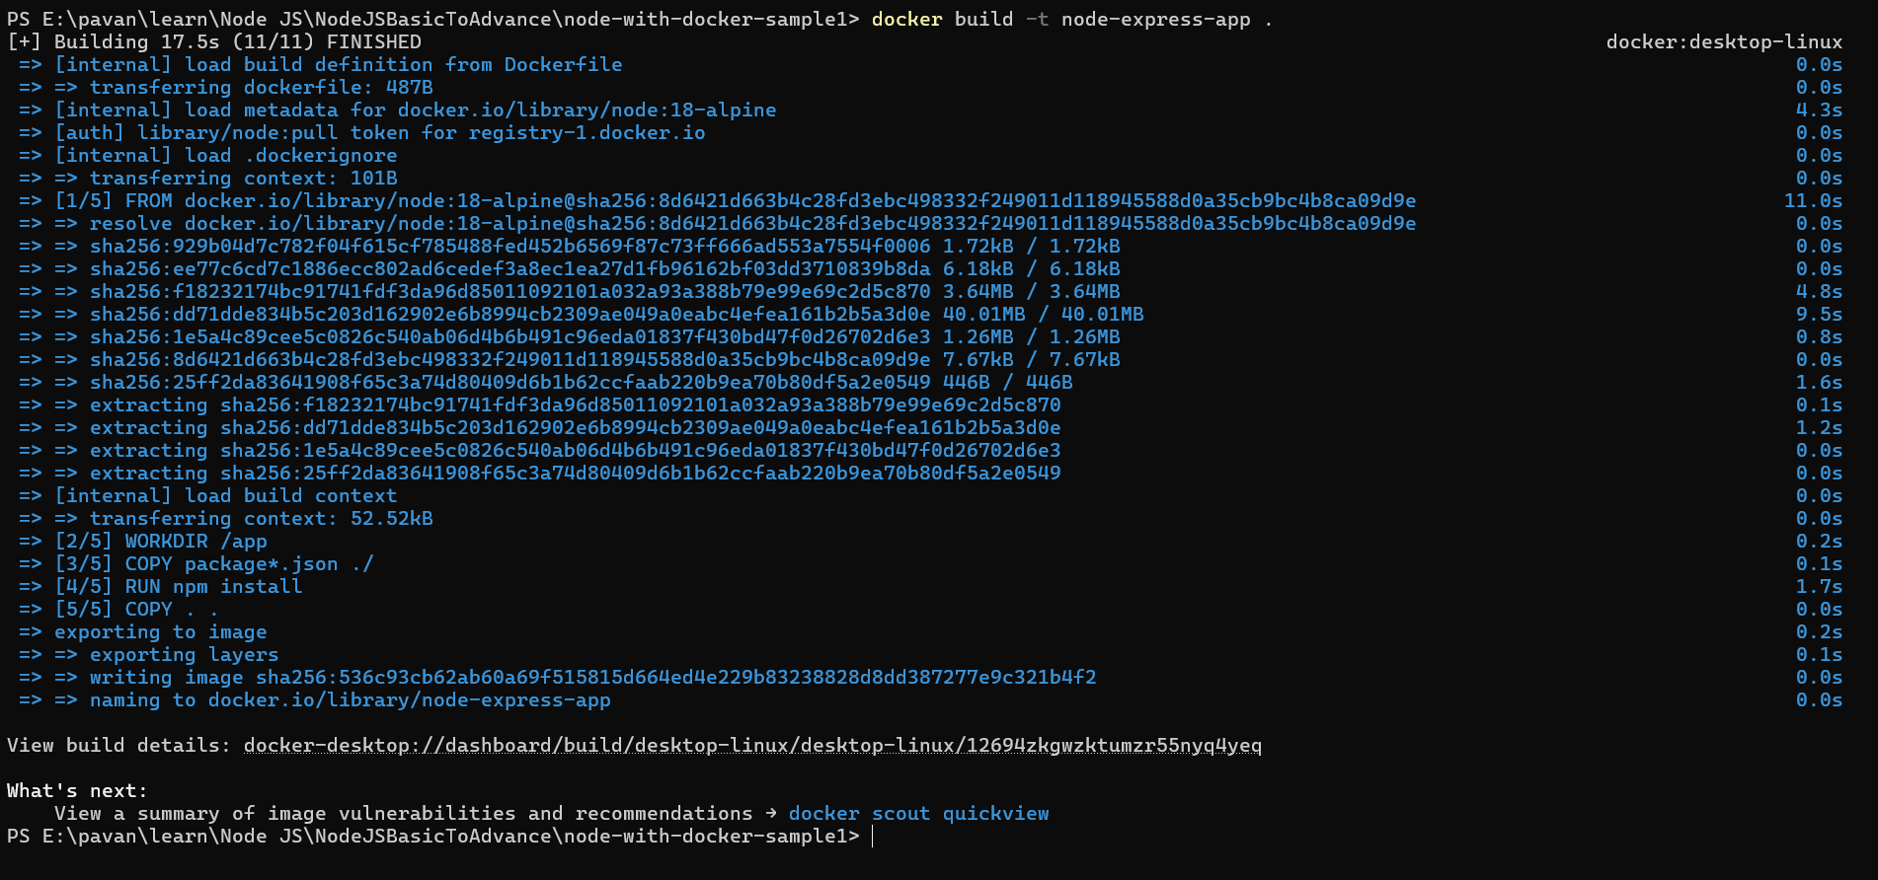

**Step 2:** Runs container from an image

**Command:** docker run -p 3000:3000 --env-file .env node-express-app

|  |  |
| --- | --- |
| **Part** | **Meaning** |
| docker run | Runs a new container from an image |
| -p 3000:3000 | Maps port 3000 on your host (left side) to port 3000 in the container (right side) |
| --env-file .env | Loads environment variables from your local .env file into the container |
| node-express-app | The image to run — the one you just built with docker build |

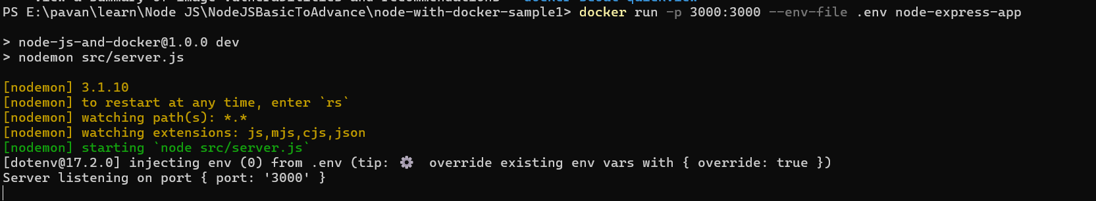

**Result:** http://localhost:3000

